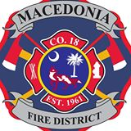

Blood Drive

2108 North Hwy 17-A Bonneau, SC

August 11, 2014 from 2pm to 7pm

@ the Macedonia fire department

**C:\Users\Fireman\AppData\Local\Microsoft\Windows\Temporary Internet Files\Content.IE5\QH712TAQ\MC900048421[1].wmf**

*Hosted by the Macedonia Fire Department Junior Explorers*

*For information Contact Junior Explorers Randy Cannon, Jr. 843-826-1959*

*Corey Port 843-934-9805*